Autorzy:

Baraniak Adrian, Błasiak Wiktor, Dmytruszyński Tomasz, Radziul Kiryl

**Work topic:**

Adoption through the eyes of a human being

**Research questions:**   
**Is adoption just simply taking someone else's child, which gives a lot of happiness? Or does it bring a lot of problems?**

**What does adoption associate with for people who don't have children versus people who already have but still want to adopt? What kind of feelings it brings?**

**Data description:**

Our data based on articles, blogs, forum comments. A total of 20 documents were collected by us, while the sum of quotations is 114. The main codes we used are reasons for adopting children, reasons for no adopting children, negative effects of adoption, positive effects of adoption, hard work connected with caring adopted children. We used metrics data like having or not having a child, marital status, having adopted or biological kids.

**Introduction**

Adoption has certainly been a popular and hard topic in recent years. There are many reasons for wanting to adopt children, some people cannot have their own, some simply want to give a new home to an adopted child, and for another it is a vocation. For sure adoption is associated with various emotions, with happiness, fulfilment, but on the other hand with fear, stress and hard moments. In the following report, we want to analyse and present to you people's opinions on the subject.

**Analysis part**

Adoption can sometimes be associated with something bad because of the popularization of stories where a child grows up, starts stealing and so on. But what is adoption really? Adoption, or adoption, comes from the Latin word adoption - which means "to take another's child as one's own, or more precisely, to adopt a person under authority (alieni curis). The term "adoption of a person under authority (alieni curis)" refers to a situation in which an adult takes into his care another person who is unable to decide for himself and his legal affairs. For terminology's sake, it looks like this, but we'll look at it through the eye of society. We collected 21 answers to the question "What is adoption?".

According to our survey of definitions, people often associate child adoption with such nouns as case, adoption (of a child), way (of having children), awareness, life, home, failures, way, happiness.

**Analysis by definition using Word Cloud**

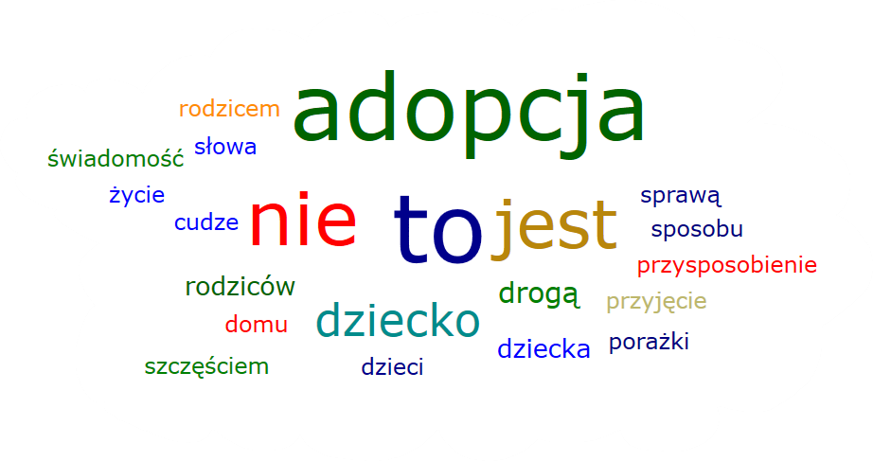

Do people who already have children, no matter if it's their own or mixed, feel more secure and stable before adopting them those people who either don't have or only have adopted children? In the course of the search for associations by us, it was noted that those who hadn’t have children or only had adoptees possibly have more fear and do not feel as stable. In addition, this fear may be related to the fact that these people want to have an adopted child but are afraid that something may go wrong due to, for example, the child's behavior, which will then affect relationships within the family. Not the least of which is worrying about, for example, whether it will be possible to give this child back in the case of such a notorious "failed adoption."

**Analysis kind of feelings adoption does it evoke in people who have a lot of children and who don't or have one**

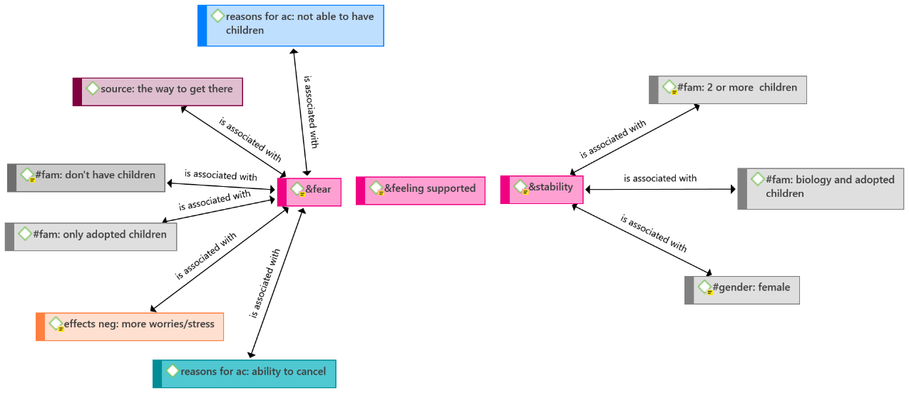

Nevertheless, adoption is a method of building a family that involves welcoming a child into one's home and providing them with a loving and supportive environment. It is an alternative way of having children that does not rely on biological connections. Through adoption, individuals or couples become legal parents to a child who may not be biologically related to them. This process offers the opportunity to provide a stable and nurturing upbringing to children who may have experienced challenging circumstances or lack a permanent home. Adoption allows individuals or couples to experience the joys and responsibilities of parenthood and create lifelong bonds with their adopted child.

**Analysis of reasons for adoption of children due to amount of having children**

|  |  |  |  |
| --- | --- | --- | --- |
| **Reasons for adoption of children** | **● #fam:**  **1 child** | **● #fam:**  **2 or more children** | **● #fam: don't have children** |
| **● reasons for ac: ability to cancel** | 0,00 | 0,04 | 0,00 |
| **● reasons for ac: altruism** | 0,03 | 0,14 | 0,00 |
| **● reasons for ac: always knew it** | 0,00 | 0,08 | 0,11 |
| **● reasons for ac: cultural embedded believes** | 0,04 | 0,00 | 0,13 |
| **● reasons for ac: feel good about trade-off** | 0,04 | 0,04 | 0,00 |
| **● reasons for ac: focusing illusion** | 0,00 | 0,00 | 0,07 |
| **● reasons for ac: for oneself / self-centered** | 0,07 | 0,12 | 0,00 |
| **● reasons for ac: influencing course of the world** | 0,00 | 0,05 | 0,00 |
| **● reasons for ac: not able to have children** | 0,06 | 0,11 | 0,14 |
| **● reasons for ac: personality** | 0,08 | 0,00 | 0,00 |
| **● reasons for ac: richer life** | 0,07 | 0,17 | 0,00 |
| **● reasons for ac: shaping a human life** | 0,17 | 0,00 | 0,06 |
| **● reasons for ac: unconditional love** | 0,00 | 0,33 | 0,00 |
| **● reasons for ac: vocation** | 0,00 | 0,18 | 0,00 |

In our study we assigned fewer than sixty codes to metric categories. We classified 23 codes to the first category “having one child”, 21 codes to the second category “having two or more children” and 14 codes to the third category “don’t have children”. We assigned many reasons for adoption of children. Each of the groups states various reasons and has different points of view in this aspect.   
 People who have one child claim that the main reason for adopting children is shaping a human life. These people emphasize that, having a child have a significant impact on changing their lifestyle and self-development. The first group doesn’t mention about reasons like: always knew it, unconditional love, vocation, which have relevant influence on people in different groups.  
 An unconditional love has a crucial impact on people who were in the second category having two or more children. They claim that children deserve unlimited love, parents should always love them even if children sometimes bring sadness, problems or difficulties. “An adopted child is a great gift, but also a successful effect, a test of mindfulness, listening carefully and understanding without words. A child needs unconditional acceptance, 100 percent of tolerance.” Significant reasons for the second group are: vocation, richer life, altruism, for oneself/self-centered, not able to have children. The vocation is the most interesting. People mention that they feel a strong need for adoption of children even if they have biological children. People want to give happiness to abandoned children. They motivate themselves to adoption by altruism and desire to give these children a better future. “An Adoption. I didn't feel pressure because I could have more children, I felt a mission and a great love for the child I didn't know”. The second group doesn’t mention about reasons like: cultural embeded believes and shaping a human life.   
 Not able to have children has a significant impact on embeded believes, always knew it, to the third category don’t have children. The third group stands out from the other groups due to not having children at all. They are more focused on different aspects of life. People mention that they desire of having children but they can’t have them because of medical aspects. For these people the adoption is an appropriate alternative. “My wife was diagnosed with endometriosis, we were both 33 years old. We considered adopting a 2-year-old boy. We were also wondering whether is it a boy or a girl... we both want a baby.” Some people state that they always knew that they want to adopt children. This group doesn’t mention about reasons like: altruism, for oneself/self centered, unconditional love and vocation.

**Analysis of reasons for no adoption children due to amount of having children**

|  |  |  |  |
| --- | --- | --- | --- |
| **Reasons for no adoption children** | **● #fam:**  **1 child** | **● #fam:**  **2 or more children** | **● #fam: don't have children** |
| **● reasons for nac: adoption prejudice** | 0,16 | 0,12 | 0,00 |
| **● reasons for nac: difficult adoption process** | 0,18 | 0,16 | 0,11 |
| **● reasons for nac: don't feel the need** | 0,00 | 0,00 | 0,15 |
| **● reasons for nac: fear about not mutual love** | 0,03 | 0,07 | 0,00 |
| **● reasons for nac: not worth the trade-off** | 0,04 | 0,00 | 0,00 |
| **● reasons for nac: partner don't want to have adoption child** | 0,00 | 0,09 | 0,00 |
| **● reasons for nac: personality** | 0,00 | 0,26 | 0,00 |
| **● reasons for nac: responsibility** | 0,03 | 0,17 | 0,00 |
| **● reasons for nac: self-centered** | 0,00 | 0,05 | 0,00 |
| **● reasons for nac: social pressure** | 0,00 | 0,14 | 0,00 |
| **● reasons for nac: state of the world** | 0,00 | 0,00 | 0,00 |
| **● reasons for nac: want to born** | 0,00 | 0,00 | 0,00 |

People state various reasons for no adoption children and have different points of view. Each group mentions that the significant problem of adoption is a difficult adoption process. People state that they experienced enormous problems during the adoption process. Adoption centers sometimes don’t let people get children due to different aspects like age of parents, not having a room for a child, financial aspects and many others. The next problem of adoption is the long-lasting process. It can last even two years. Adoption centers teach people how to care, deal with children and carry out the adoption process. “When my husband and I tried for our first daughter, we considered adopting but a bucket of cold water was poured on our heads.... The adoption requires from future parents 5 years of marriage and it depends on good opinion of the family. Adopting training and courses last almost 2 years.” The significant factor for no adoption children is an adoption prejudice, especially for people who have already had a child or children. Family, friends, environment warn future parents against bad background and unknown genes of adoption child. They claim that bad background have a significant impact on future attitude of the child. This stereotype has wrong effect on people who want to adopt a child. “Some parents have to oppose the environment. The adoption is not always well accepted by a family or friends.” The second group claim that personality and responsibility have meaningful impact on themselves. They say that childcare require dealing with a lot of difficulties and being mindful. They sometimes don’t believe in their abilities and they explain difficulty by their personality. People experience even adoption depression during the first moments of taking care of an adopted child. People who don’t have children claim that they don’t feel the need to adopt a child. Each group don’t mention about reasons like: state of the world, want to born.

**Analysis of reasons for adoption children due to social status**

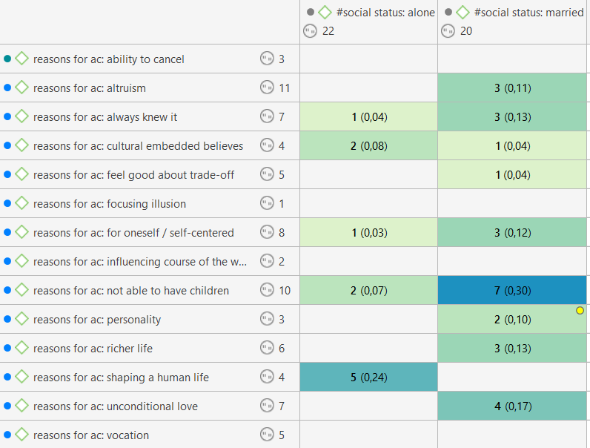

In the next step, we examined the reasons for adoption indicated by single individuals and married couples. The results yielded several interesting conclusions. Single individuals most commonly cited the desire to share their lives with someone, whereas this response did not appear in any case among married couples. This raises the question of whether single individuals want to adopt a child because they feel lonely in life. Interestingly, single individuals did not indicate unconditional love as their reason, whereas for couples, it was the second most frequently cited reason for adopting a child. The most frequently cited reason among married couples for adopting a child was the inability to have biological children. From reading individual statements, we learn that married couples often choose to adopt children due to health reasons or infertility, which prevents them from having biological children.

**Analysis of neg. and pos. effects of adoption children due to amount of having children**

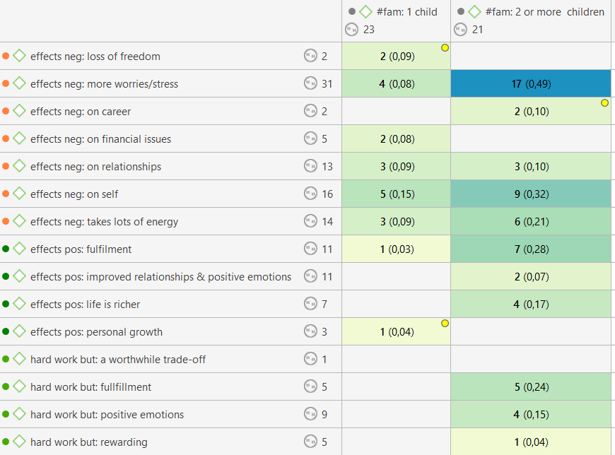

This time, we examined the effects of adoption separately among individuals with one child and those with two or more children. However, due to limited data in the first group, we decided to present the results collectively for both groups, considering notable cases. Individuals who had one child predominantly indicated negative outcomes resulting from adopting a child rather than positive ones, although this trend was observed in both categories. Both groups agreed and most frequently cited the same two negative effects. In 21 instances, out of which 17 occurred among individuals with at least two children, a significantly higher level of stress and concerns after adopting children was adopted. The second most frequently cited effect, in 14 instances, out of which 9 were by individuals with at least two children, was that adoption had a negative impact on the adoptive parents themselves. Another commonly mentioned negative effect of adoption was the amount of energy it requires. The most frequently cited positive effect turned out to be fulfilment. Individuals who adopted children also expressed that their lives became richer after adoption. Some individuals also indicated that adoption involves a lot of work and sacrifices, but ultimately brings forth many positive emotions and fulfilment.

**Analysis amount of all reasons for and against adoption children**

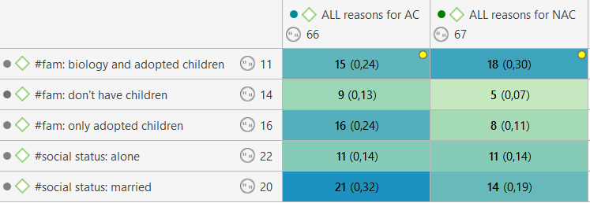

In the summary analysis, we combined all the reasons for adopting children and not adopting children. We assigned groups of codes to them - gender, social status and whether they have children or not. People without children or those with only adopted children were much more likely to write reasons (about twice as often) for adopting children (25 times for adopting and 13 times for not adopting). On the other hand, what is interesting, people with both - their own and adopted children spoke much more often than in previous cases about the reasons for not having children (18 times for not adopting and 15 times for adopting).  
 This is probably due to the fact that children can disagree with each other which causes much more problems in a family that negatively favor adoption, such as favoring own child.   
When it comes to social status, the group of married people is definitely more ready to have children, so they more often speak positively about the reasons for adoption. Interestingly, they also regularly write about the negative effects of having adoptive children than the positive ones. They cite effects such as worsened relationships, more worries or less fun/satisfaction. After all they are ready to endure many bad moments to give the child a chance for a better life.

**Summary and main conclusions**

The survey discusses the concept of adoption and explores various perspectives and reasons behind it. Adoption is described as the process of taking another person's child as one's own, providing them with a loving and supportive environment. It is an alternative way of building a family that does not rely on biological connections, allowing individuals or couples to become legal parents to a child who may not be biologically related to them.

The analysis highlights that people who already have children, whether biological or adopted, may feel more secure and stable before adopting additional children compared to those who have no children or only have adopted children. The fear and insecurity in the latter group may stem from concerns about the child's behavior and how it may affect family dynamics, as well as the possibility of a "failed adoption."

Different groups of people have distinct reasons for adopting children. Those with one child often emphasize the transformative impact of having a child on their lifestyle and self-development. People who have two or more children prioritize unconditional love and believe that children deserve unlimited affection and acceptance, regardless of their origins. They also mention altruism, vocation, and the desire to give abandoned children a better future as motivating factors for adoption.

For people who do not have children, adoption serves as an appropriate alternative when they are unable to have biological children due to medical reasons. Some individuals in this group express a lifelong desire to adopt children, while others see it as a viable option to fulfil their parenting aspirations. Interestingly, families who already have an adopted and their own child more often write about the reasons for not adopting. This may suggest that in these families there are more challenges and problems associated with this process.

The analysis also acknowledges the challenges and difficulties associated with the adoption process. Lengthy waiting periods, strict criteria set by adoption centers, and societal prejudices are mentioned as obstacles. The negative effects of adoption include increased stress levels and concerns, as well as the significant amount of energy required to care for an adopted child. However, people also mention positive outcomes, such as fulfillment, enriched lives, and the joy of creating lifelong bonds with their adopted children.

The analysis also explores the reasons for adoption among single individuals and married couples. Single individuals commonly express the desire to share their lives with someone, potentially indicating a sense of loneliness. Married couples frequently cite the inability to have biological children as a primary reason for adoption, often due to health issues or infertility. It can also be emphasized that marriages from single people also write many more reasons for adoption child than against it.

The findings of the study suggest that individuals with one child tended to report more negative outcomes from adopting a child compared to individuals with two or more children, although negative effects were observed in both groups. The two most commonly cited negative effects were a higher level of stress and concerns, particularly among those with at least two children, and a negative impact on the adoptive parents themselves. Adoption was also seen as requiring a significant amount of energy. On the positive side, the most frequently mentioned effect was fulfillment, with individuals expressing that their lives became richer after adopting a child.